 | Title : Project Registration & Progress Review |  | FF No. 180
Department: Computer Engineering |  | Academic Year: 2026-27
Semester: 07 |  | Group No.: 28
Project Title: AutoForensic AI: An AI Powdered Car Damage Assessment System
Project Area: Computer Vision, AI, Cybersecurity & Digital Media Forensic
Group Members Details:

Sr. No. | Class & Div. | Roll No. | G.R.No. | Name of Student | Contact No. | Email ID
1 | BTech | 112 | 12310769 | Pranit Kothari | 9172887506 | pranit.kothari23@vit.edu
2 | BTech | 198 | 12311463 | Siddhant Devsale | 8669024432 | siddhant.devsale231@vit.edu
3 | BTech | 199 | 12311333 | Mangesh Devikar | 7796329545 | mangesh.devikar231@vit.edu
4 | BTech | 184 | 12310469 | Vedant Gaikwad | 7620544089 | vedant.gaikwad23@vit.edu

Name of Internal Guide: Dr. Vikas Kolekar
Contact No. & Email ID: 8055822246 & vikas.kolekar@vit.edu

Project approved / Not approved

Dr. Vikas Kolekar Dr. Ranjeetsingh Suryawanshi Prof.(Dr.) S.R.Shinde
Guide Project Coordinator Head,
Department of Computer Engineering

T

FF No 180

Project Synopsis

Project Description:
AutoForensic AI is a cloud-based enterprise platform that automates vehicle damage assessment and prevents insurance fraud by unifying cybersecurity, computer vision, and full-stack cloud engineering. The system proactively screens uploaded media for digital tampering, fake metadata, and duplicate submissions before any visual analysis begins. Authentic images are then processed using a YOLOv8-Seg neural network to precisely outline damages with polygon masks, while monocular depth models estimate the physical depth and surface area. Based on these precise visual metrics, the platform automatically calculates itemized repair costs and generates a certified final PDF assessment report, which is secured with an immutable SHA-256 cryptographic hash to guarantee absolute data integrity.

Problem Statement:
Traditional vehicle damage inspections are slow and manual workflows, costing the global insurance industry billions annually in administrative overhead and "claims leakage". While academic computer vision models can detect car damage, they blindly trust input images, leaving organizations highly vulnerable to digital fraud via manipulated photos or AI-generated synthetic damage. Furthermore, standard AI models only draw flat 2D bounding boxes around damage, failing to calculate the physical surface area or depth dimensions required for accurate repair pricing. There is a critical need for an end-to-end, production-ready system that integrates computer vision into a secure, scalable, full-stack cloud environment with built-in fraud defenses.

Project Objectives:
- Implement Media Forensics: Validate image authenticity using Error Level Analysis (ELA), EXIF metadata checks, and perceptual hashing to identify duplicate or digitally manipulated photos.
- Deploy Instance Segmentation: Utilize a fine-tuned YOLOv8-Seg model to accurately outline the exact boundaries of vehicle exterior damages (such as scratches, dents, and cracks) using sub-pixel polygon masks.
- Calculate Volumetric Severity: Integrate monocular depth estimation models to measure the physical depth and real-world surface area ($cm^2$) of the damage, moving beyond simple 2D coordinates.
- Automate Repair Cost Reasoning: Build an inference rule engine that calculates itemized parts and labor costs automatically based on the AI's spatial and categorical findings.

FF No 180

System Architecture:

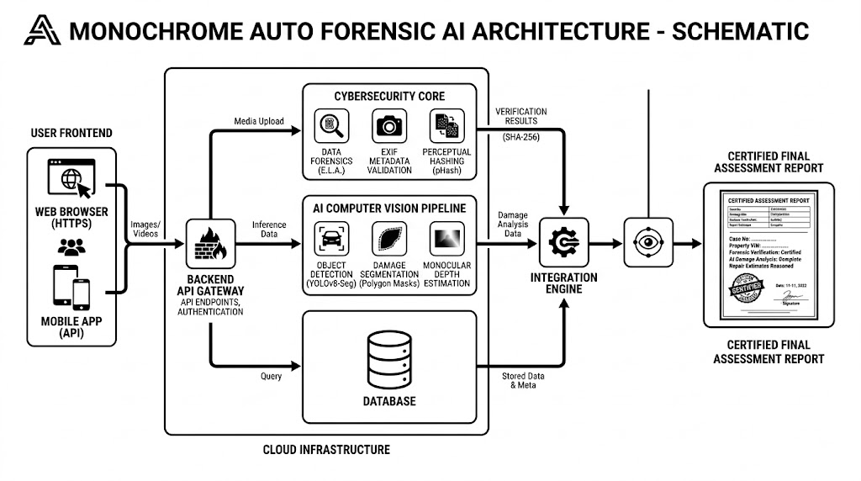

FF No 180

Group No.
Activity | Review Schedule | Progress Review Report submitted | Signature of Guide
Review 1 | Mid Sem. Semester | Yes / No
Review 2 | End of Semester | Yes / No

Format of Progress Review Report:

Review No.: 1 Group No.: Date:

Progress Review Report

Signature of Guide:
FF No 180

Review No.: 2 Group No.: Date:

Progress Review Report

Signature of Guide:

